PRANAV RAIKAR

D15A 47

Experiment 3:

AIM: To include images and fonts in flutter app.

Theory:

Theory: Certainly! Here's a simplified process for adding images in Flutter:

1. Import Libraries:

Ensure that you have the necessary libraries imported in your Dart file. For images, you'll

typically use `dart:ui` and other relevant Flutter packages.

2. Adding Local Images:

- Place your local images in the `assets` folder.

- Declare the images in the `pubspec.yaml` file.

3. Adding Network Images:

- Use the `Image.network` widget for displaying images from the internet.

4. Image Widget:

- Create an `Image` widget and provide it with an `ImageProvider`.

- Use `AssetImage` for local images and `NetworkImage` for network images.

5. ImageProvider:

- Understand that `AssetImage` and `NetworkImage` are subclasses of the `ImageProvider`

class.

- You can create custom `ImageProvider` if needed.

6. CachedNetworkImage (Optional):

- If you want to cache network images, consider using the `cached_network_image` package.

7. Image Loading and Error Handling:

- Customize the loading and error behavior using `loadingBuilder` and `errorBuilder`

properties of the `Image` widget or other relevant widgets.

Remember, the actual implementation details might vary based on your specific use case and

the packages you choose to use. The key is to understand the concepts of working with local

and network images and the various widgets and packages available in Flutter for handling

images.

Code:

import 'package:flutter/material.dart';

import 'package:food_panda/widget/widget_support.dart';

class Details extends StatefulWidget {

const Details({super.key});

@override

State<Details> createState() => _DetailsState();

}

class _DetailsState extends State<Details> {

int a = 1;

@override

Widget build(BuildContext context) {

return Scaffold(

body: Container(

margin: EdgeInsets.only(top: 50.0, left: 20.0, right: 20.0),

child: Column(

crossAxisAlignment: CrossAxisAlignment.start,

children: [

GestureDetector(

onTap: () {

Navigator.pop(context);

},

child: Icon(

Icons.arrow_back_ios_new_outlined,

color: Colors.black,

)),

Image.asset(

"images/salad2.png",

width: MediaQuery.of(context).size.width,

height: MediaQuery.of(context).size.height / 2.5,

fit: BoxFit.fill,

),

SizedBox(

height: 15.0,

),

Row(

children: [

Column(

crossAxisAlignment: CrossAxisAlignment.start,

children: [

Text(

"Mediterranean",

style: AppWidget.semiBoldTextFieldStyle(),

),

Text(

"Chickpea Salad",

style: AppWidget.boldTextFieldStyle(),

),

],

),

Spacer(),

GestureDetector(

onTap: () {

if (a > 1) {

--a;

}

setState(() {});

},

child: Container(

decoration: BoxDecoration(

color: Colors.black,

borderRadius: BorderRadius.circular(8)),

child: Icon(

Icons.remove,

color: Colors.white,

),

),

),

SizedBox(

width: 20.0,

),

Text(

a.toString(),

style: AppWidget.semiBoldTextFieldStyle(),

),

SizedBox(

width: 20.0,

),

GestureDetector(

onTap: () {

++a;

setState(() {});

},

child: Container(

decoration: BoxDecoration(

color: Colors.black,

borderRadius: BorderRadius.circular(8)),

child: Icon(

Icons.add,

color: Colors.white,

),

),

)

],

),

SizedBox(

height: 20.0,

),

Text(

"A special and delicious salad.This salad consists of different fibrous veggie.The special ingredient used Letus,cucumber,tomato,cabage,checkpeas,corn.There is a pinch of spice and lime juice which makes the salad more delicious",

maxLines: 4,

style: AppWidget.LightTextFieldStyle(),

),

SizedBox(

height: 30.0,

),

Row(

children: [

Text(

"Delivery Time",

style: AppWidget.semiBoldTextFieldStyle(),

),

SizedBox(

width: 25.0,

),

Icon(

Icons.alarm,

color: Colors.black54,

),

SizedBox(

width: 5.0,

),

Text(

"30 min",

style: AppWidget.semiBoldTextFieldStyle(),

)

],

),

Spacer(),

Padding(

padding: const EdgeInsets.only(bottom: 40.0),

child: Row(

mainAxisAlignment: MainAxisAlignment.spaceBetween,

children: [

Column(

crossAxisAlignment: CrossAxisAlignment.start,

children: [

Text(

"Total Price",

style: AppWidget.semiBoldTextFieldStyle(),

),

Text(

"\$28",

style: AppWidget.HeadlineTextFieldStyle(),

)

],

),

Container(

width: MediaQuery.of(context).size.width / 2,

padding: EdgeInsets.all(8),

decoration: BoxDecoration(

color: Colors.black,

borderRadius: BorderRadius.circular(10)),

child: Row(

mainAxisAlignment: MainAxisAlignment.end,

children: [

Text(

"Add to cart",

style: TextStyle(

color: Colors.white,

fontSize: 16.0,

fontFamily: 'Poppins'),

),

SizedBox(

width: 30.0,

),

Container(

padding: EdgeInsets.all(3),

decoration: BoxDecoration(

color: Colors.grey,

borderRadius: BorderRadius.circular(8)),

child: Icon(

Icons.shopping_cart_outlined,

color: Colors.white,

),

),

SizedBox(

width: 10.0,

),

],

),

)

],

),

)

],

),

),

);

}

}

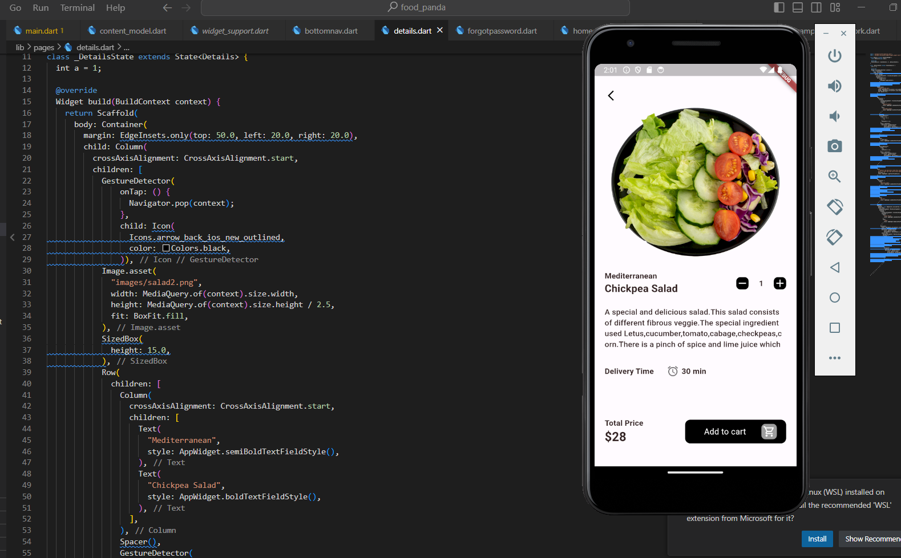

In above screenshot I have used Image.asset method to add a image

Conclusion :Thus I learnt to how to add images in our flutter app